

**DATA ANALYSIS OF WORKING CAPITAL MANAGEMENT USING TABLEAU**

**PROJECT REPORT**

***Table of Contents***

***Topic: Data Analysis of Working Capital Management using Tableau ………………...................................................................................................................................................... 1***

***Summary .............................................................................................................................................................................. 3***

***Aim of the Project .............................................................................................................................................................................. 4***

***Data Description .............................................................................................................................................................................. 5***

***Loading the Data .............................................................................................................................................................................. 7***

***Building Dashboards in Tableau .............................................................................................................................................................................. 9***

***Conclusion ............................................................................................................................................................................ 12***

***SUMMARY***

Working capital optimization is a critical aspect of financial management that emphasizes the efficient handling of a company’s short-term assets and liabilities. The primary goal is to ensure that the organization has adequate liquidity to support day-to-day operations while simultaneously minimizing the costs associated with maintaining working capital.

This process involves carefully balancing three key components:

* **Inventory Management –** Maintaining the right level of inventory to avoid both stockouts and excess holding costs.
* **Accounts Receivable –** Implementing strategies to accelerate collections from customers, thereby improving cash inflows.
* **Accounts Payable –** Managing supplier payments in a way that maximizes available credit terms without harming business relationships.

By optimizing these elements, companies can:

* Unlock additional **cash flow** that would otherwise remain tied up in operations.
* **Reduce borrowing costs** by lowering dependency on external financing.
* **Enhance financial stability** through improved liquidity ratios.
* Reinvest freed-up resources into **growth opportunities** such as innovation, expansion, or new product development.

Overall, effective working capital optimization acts as a bridge between operational efficiency and strategic financial planning, ensuring that businesses not only sustain smooth operations but also build the capacity to grow in a competitive environment.

***AIM OF THE PROJECT***

The primary aim of this project is to conduct a comprehensive **data-driven analysis** of receivables and payables using Tableau, with the overarching goal of optimizing **working capital management**. By leveraging Tableau’s powerful visualization and analytical capabilities, the project seeks to transform raw financial data into **actionable insights** that can enhance liquidity, streamline operations, and improve overall financial performance.

**Key Objectives**

1. **Visualize Receivables and Payables Data**
   * Track outstanding customer payments and supplier obligations.
   * Identify patterns and bottlenecks in payment cycles.
2. **Optimize Cash Flow Strategies**
   * Highlight overdue accounts and delayed payments.
   * Provide insights into optimal credit and payment terms.
   * Support strategies to accelerate collections and extend payables effectively.
3. **Develop Interactive Dashboards**
   * Create dedicated **Accounts Receivable (AR)** dashboards to monitor customer payment trends, DSO (Days Sales Outstanding), and overdue invoices.
   * Design **Accounts Payable (AP)** dashboards to analyze vendor payment timelines, DPO (Days Payable Outstanding), and early-payment discount opportunities.
4. **Leverage Tableau Features**
   * Utilize Tableau connectors for integrating diverse financial data sources.
   * Apply Tableau’s advanced functionalities (calculated fields, trend lines, filters, and drill-downs) for deeper analysis.
5. **Enable Data-Driven Decision-Making**
   * Equip finance teams with dynamic dashboards that update in real time.
   * Provide senior management with insights to **refine financial strategies**, ensure liquidity, and improve working capital efficiency.

***DATA DESCRIPTION***

The dataset for this project is divided into three main categories: **Customer Data**, **Receivables Data**, and **Suppliers & Payables Data**. Together, these datasets provide a comprehensive view of the company’s working capital cycle, covering both **inflows (accounts receivable)** and **outflows (accounts payable)**. The integration of these datasets in Tableau will allow for in-depth visualization and analysis of liquidity, payment cycles, and credit management.

**Customer Data**

The **Customer Data** segment contains the foundational information required to identify and classify customers for receivables analysis. It includes the following attributes:

* **Customer ID**: A unique identifier for each customer, ensuring accuracy in linking transactional data.
* **Customer Name**: The registered name of the customer.
* **Customer Payment Terms**: Predefined contractual terms outlining when and how customers are expected to settle payments.
* **Address**: The geographical location of the customer, useful for region-based analysis.
* **Credit Limit**: The maximum amount of credit extended to the customer, which plays a crucial role in monitoring risk exposure.

**Receivables Data**

The **Receivables Data** captures detailed information about customer invoices and payments, serving as the backbone for analyzing inflows of cash. It contains the following attributes:

* **Business Code**: Identifies the type of business transaction.
* **Customer Number / Name**: Links invoices to customers.
* **Payment Date / Posting Date / Due Date / Baseline Date**: Key dates that help calculate invoice aging, overdue status, and collection timelines.
* **Business Year**: Specifies the fiscal year of the transaction.
* **Payterm**: Defines the credit terms applicable to the invoice.
* **Invoice Currency / USD_CURRENCY**: Ensures proper handling of multi-currency invoices by enabling conversion to a standard USD value.
* **Total Open Amount / Total Open Amount (USD)**: Represents the outstanding amount for each invoice, both in local and standardized currency.
* **Invoice ID**: Unique reference for each invoice.
* **Is Open**: Tracks whether an invoice is open or settled.
* **DUNNLEVEL**: Indicates the aging status of overdue invoices, reflecting the number of collection attempts and the severity of overdue.
* **Credit Limit**: Assigned limit for the respective customer to monitor risk exposure.
* **Region**: Helps in geographical segmentation of receivables.

**Supplier Data**

The **Supplier Data** captures descriptive details of vendors and their classifications, which form the basis of payables analysis:

* **Supplier ID**: Unique identifier for each supplier.
* **Supplier Name**: The registered name of the supplier.
* **Payment Terms**: The conditions under which the supplier expects payment.
* **Vendor Type**: Classification of the supplier by type (e.g., raw material, services).
* **Supplier Category**: Further categorization to understand expenditure distribution.

**Payables Data**

The **Payables Data** tracks all company obligations toward suppliers and vendors. It includes critical attributes that influence outflow management:

* **Invoice Number / Invoice Date / Posting Date**: Tracks the lifecycle of each invoice.
* **Payment Date / Net Due Date**: Indicates actual versus expected settlement dates.
* **Supplier ID**: Connects payables to suppliers.
* **Invoice Amount / Total Outstanding Amount**: Captures both settled and pending obligations.
* **Fiscal Year**: Identifies the financial year for analysis.
* **Overdue**: Flags invoices past their due date.
* **Invoice Status**: Current state of the invoice (paid, unpaid, outstanding).
* **Spend Category**: Classification of expenditure (e.g., operating expenses, capital expenses).
* **Late Payment Fees**: Tracks penalties for missed deadlines.
* **Payterm_n**: Payment terms applicable to the supplier’s invoice.
* **Vendor Type**: Provides insight into the type of supplier linked to the invoice.

**Integration Value**

Together, these datasets form a **360-degree view of working capital**:

* **Customer + Receivables Data** → Helps track inflows and assess credit risks.
* **Supplier + Payables Data** → Provides visibility into outflows and vendor obligations.
* **Combined Analysis** → Facilitates a balanced approach to optimizing working capital by comparing receivables versus payables and forecasting liquidity needs.

***LOADING THE DATA***

**i)Objective**

Provision a managed **Microsoft SQL Server** database on **Amazon RDS**, then load all AR/AP/Customer/Supplier Excel datasets into normalized tables to power Tableau dashboards

**ii)Prerequisites**

* AWS account with permissions for RDS + VPC + Security Groups
* **SQL Server Management Studio (SSMS)** on your laptop
* Source files (Excel/CSV) for **Customers, Receivables, Suppliers, Payables**
* Stable network; your public IP (to allow DB access)

**iii)Create the RDS SQL Server Instance**

1. **Sign in to AWS Console** → search **RDS** → **Create database**.
2. **Engine options:** *Microsoft SQL Server* (Express/Standard/Developer per need).
3. **Templates:** Dev/Test.
4. **Settings**
   * DB instance identifier: working-capital-optimization-db
   * Master username: admin (or your chosen)
   * Master password: set & store securely
5. **Instance class & storage**
   * db.t3.small (demo) | GP3 storage 20–50 GB, enable Auto Scaling (optional)
6. **Connectivity**
   * VPC: default (or your project VPC)
   * **Public access:** *Yes* (for demo) → will open SG to your IP only
   * **VPC security group:** new SG wcmsql-sg with inbound **TCP 1433** from *My IP*
   * Port: **1433**
7. **Additional configuration**
   * Initial DB name: leave blank (we’ll create later)
   * Backup: 1–7 days (default OK)
   * Encryption: enable if available
8. **Create database** and wait until status = **Available**.
9. Open the instance page and copy the **Endpoint** (e.g., wcmsql.abcd1234.region.rds.amazonaws.com).

**iv)Connect from SSMS**

1. Open **SSMS** → **Connect** → **Database Engine**.
2. **Server name:** paste the **Endpoint** (no https://).
3. **Authentication:** *SQL Server Authentication*
4. **Login:** admin | **Password:** your master password
5. **Connect**. If blocked, confirm your IP is allowed in the security group.

**v)Create the Project Database & Schemas**

In SSMS:

* **Databases** → **New Database…** → name: WCM_Analytics → **OK**.

## **vi)Import the Excel Files (SSMS Import Wizard)**

For each Excel/CSV file:

1. In SSMS: right-click **WCM_Analytics** → **Tasks** → **Import Data…**
2. **Data Source:**
   * If Excel: **Microsoft Excel** → select file → choose the correct Excel version
   * (More robust) Convert to **CSV** first and choose **Flat File Source**
3. **Destination:** **.NET Framework Data Provider for SQL Server** (or SQL Server Native Client).
4. Enter RDS endpoint, database WCM_Analytics, username/password.
5. **Select Source Tables and Views** → map each worksheet/file to the target table (e.g., Receivables → wcm.Receivables).
6. **Column Mappings:** verify datatypes & lengths; fix mismatches (e.g., dates, numeric).
7. **Run immediately** → finish → confirm success rows.
8. Repeat for **Customers**, **Suppliers**, **Payables**.

## **vii)Connect Tableau to RDS (SQL Server)**

1. Open **Tableau Desktop** → **Microsoft SQL Server** connector.
2. **Server:** paste RDS **Endpoint** (no port needed if default 1433).
3. **Database:** WCM_Analytics
4. **Authentication:** Username/Password → enter admin + password → **Sign In**.
5. Drag tables (or custom SQL). Create relationships between **Customers ↔ Receivables** and **Suppliers ↔ Payables** using keys.

***BUILDING DASHBOARDS IN TABLEAU***

The central analytical component of this project was the development of two interactive dashboards in Tableau. These dashboards consolidate data from **AWS RDS (SQL Server)**, transform raw financial data into meaningful insights, and provide decision-makers with a clear view of receivables and payables performance.

### Dashboards Created

1. **Accounts Receivable (AR) Dashboard**
2. **Accounts Payable (AP) Dashboard**

Both dashboards use **Posting Date** as the time dimension for consistency, and calculated fields were applied to classify payments (Early, On-time, Late) for advanced analysis.

### **Steps to Build Dashboards in Tableau**

* **Connect Tableau to SQL Server (AWS RDS)**
  + Select Microsoft SQL Server as the connector.
  + Enter server endpoint, database, and credentials.
* **Choose Tables**
  + Import the relevant tables: Customers, Receivables, Suppliers, Payables.
  + Establish relationships between tables (e.g., Customer ID ↔ Receivables, Supplier ID ↔ Payables).
* **Data Preparation**
  + Check and adjust all data types (dates, amounts, text).
  + Create calculated fields for advanced analysis, such as:

IF INT([Due Date] - [Payment Date]) = 0 THEN 'On-time'

ELSEIF INT([Due Date] - [Payment Date]) < 0 THEN 'Late'

ELSE 'Early'

END

* + This classification was applied in both dashboards to segment payment behaviors.
* **Build Visualizations**
  + Create individual sheets for KPIs, charts, and tables.
  + Use filters and calculated fields to enrich insights.
* **Design Dashboards**
  + Combine individual sheets into dashboards.
  + Align objects using horizontal/vertical containers.
  + Add interactive filters (by region, customer, supplier, or fiscal year).
  + Refine the layout for readability and user experience.
* The final dashboards (AR & AP) were exported in two formats:
  + **PDF/PNG exports** for inclusion in the written project report.
  + **Tableau Packaged Workbook (.twbx)** for submission and demonstration purposes.
* This ensured that evaluators could view the dashboards both as **static reports** and as **interactive dashboards** if they had Tableau installed.
* Additionally, an optional **Tableau Public link** was generated to make the dashboards accessible online, demonstrating the project’s real-world applicability.

### **Accounts Receivable Dashboard**

**Key KPIs:**

* Total Receivables
* Total Open Amount
* Average Time to Receive
* Total Customers
* Payment Status Breakdown (Early, On-time, Late)

**Visuals Included:**

* Top 30 Customers by Receivables (bar chart)
* Receivables Aging Over Time (line chart)
* Receivables by Region (pie chart)
* Average Days to Receive Payment by Customer (treemap)

📊 This dashboard highlights overdue invoices, identifies high-risk customers, and tracks collection efficiency across customers and regions.

Public link : [***https://public.tableau.com/app/profile/nishanth.manoharan/viz/ACD_17577025663820/Dashboard1?publish=yes***](https://public.tableau.com/app/profile/nishanth.manoharan/viz/ACD_17577025663820/Dashboard1?publish=yes)

### **Accounts Payable Dashboard**

**Key KPIs:**

* Total Payables
* Total Invoice Amount
* Total Late Payment Fees
* Total Suppliers
* Payment Status Breakdown (Early, On-time, Late)

**Visuals Included:**

* Top 30 Suppliers by Payables (bar chart)
* Payments by Spend Category and Vendor Type (bubble chart)
* Paid vs. Unpaid Invoices (pie chart)
* Payables by Spend Category (pie chart)

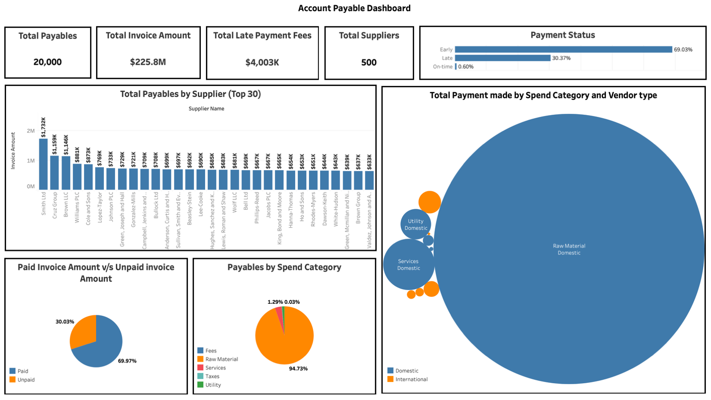📊 This dashboard provides visibility into supplier obligations, spending patterns, and the financial impact of late payments.

*Public link :*[***https://public.tableau.com/app/profile/nishanth.manoharan/viz/APD_17577054493020/Dashboard1?publish=yes***](https://public.tableau.com/app/profile/nishanth.manoharan/viz/APD_17577054493020/Dashboard1?publish=yes)

***CONCLUSION***

The project on **Data Analysis of Working Capital Management using Tableau** successfully demonstrated how data visualization can transform raw financial data into actionable insights for better decision-making. By integrating customer, receivables, supplier, and payables data into Tableau, the project enabled a holistic view of a company’s short-term financial health.

Through the development of two interactive dashboards—**Accounts Receivable Dashboard** and **Accounts Payable Dashboard**—stakeholders can now:

* Monitor receivables and payables trends in real time.
* Identify overdue invoices and late payments.
* Analyze customer and supplier performance.
* Track KPIs such as DSO (Days Sales Outstanding) and DPO (Days Payable Outstanding).
* Improve liquidity management by balancing cash inflows and outflows.

The use of **calculated fields and advanced analytics** (e.g., payment status classification, posting date trends) further enhanced the dashboards’ ability to uncover patterns in financial transactions. Exporting dashboards as **PNG/PDF reports and packaged workbooks** also ensured accessibility for both static presentation and interactive exploration.

Overall, the project highlights the value of **business intelligence tools like Tableau** in optimizing working capital, reducing financial risks, and enabling organizations to strengthen their financial stability while supporting long-term growth.